March 2026

Parent/Carer Survey Results – 2026

Families completed our annual Me2 Club survey for 37 young people, which was live from 27 January to 28 February 2026.
Overall, 100% of families would recommend us to other families.
About our families
We had responses from 26% of the families that we work with in line with previous years. The families who responded were representative of our families as a whole. 34% of young people are in receipt of free school meals and 44% are from global majority populations:
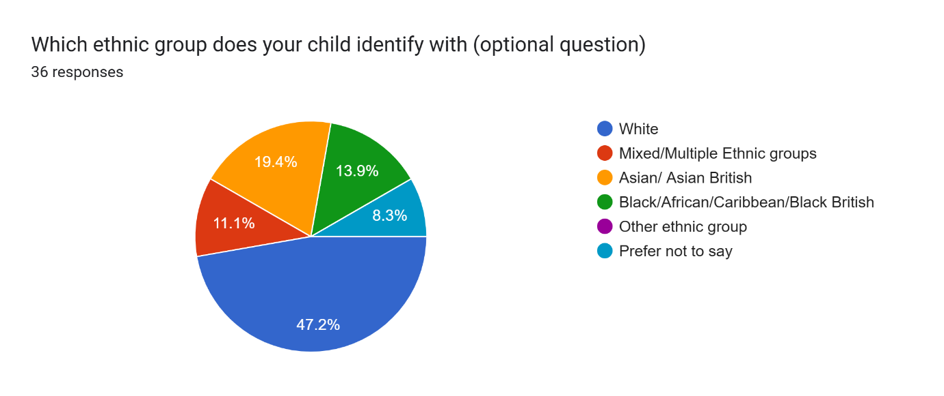
6% are SNG residents and a further 3 families were not sure.

The young people attend a range of our services as below. Please note that many of our young people attend more than one of Me2 Club’s activities
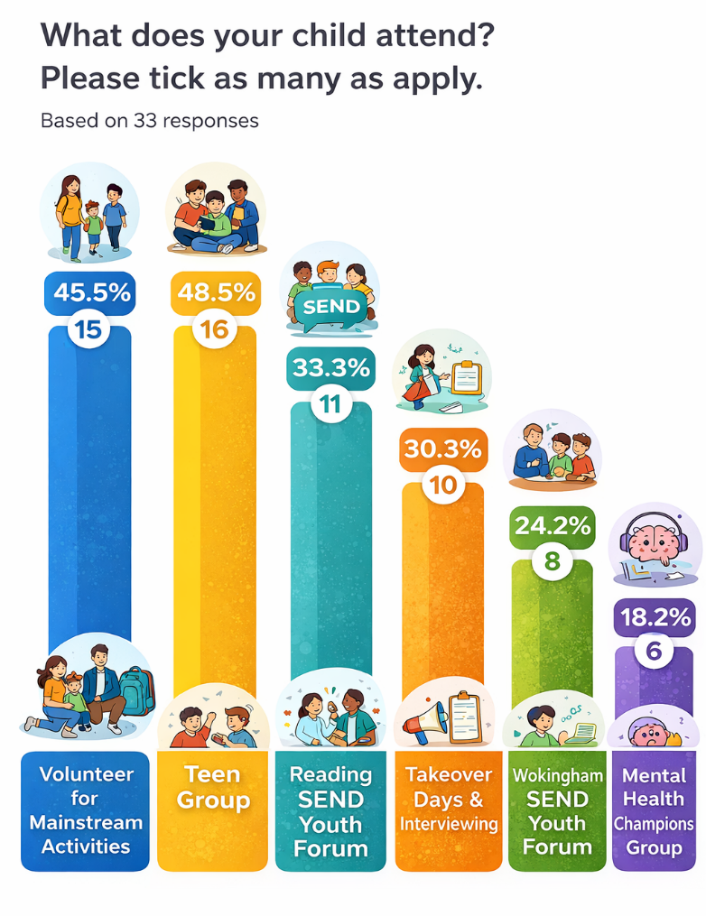

Our Impact
Me2 Club aims to improve children and young people’s independence, confidence and social connections.
91% of families said that their children had fun: 67% of families gave 5/5 stars and 24% gave 4/5 stars.
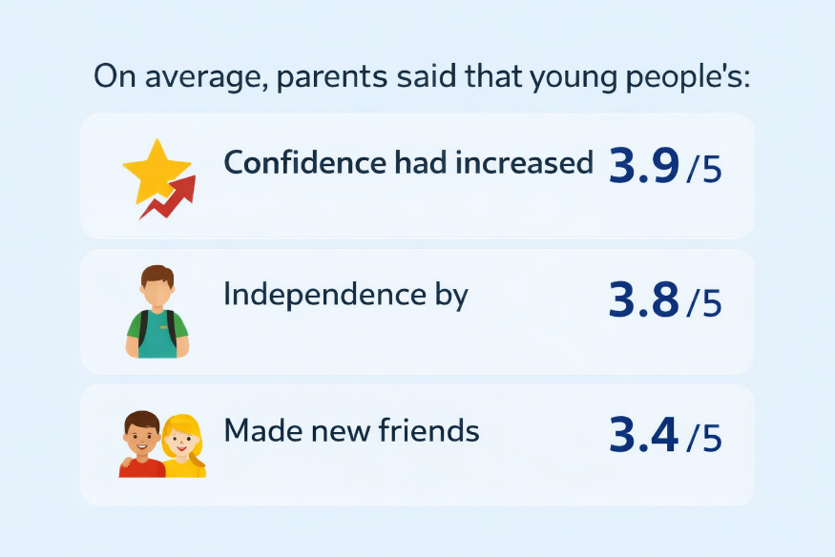

Me2 Club are proud that so many of our families continue to allow us to support their children and young people:
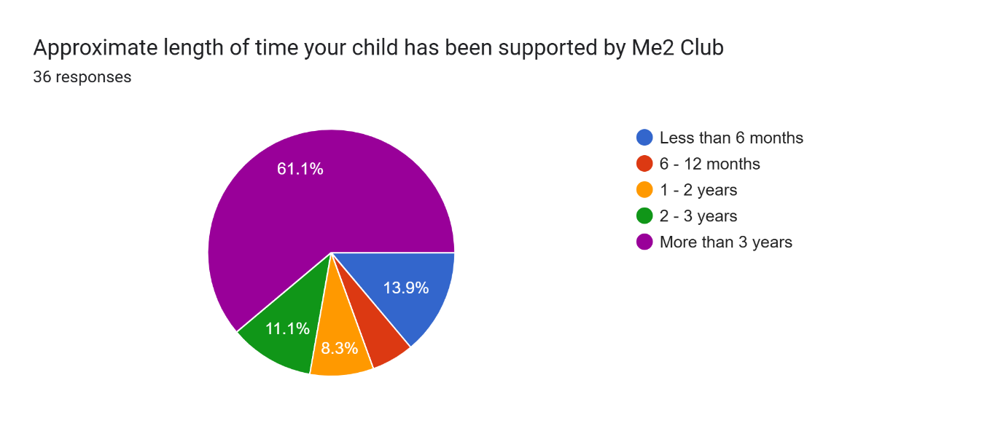

This is what some of our parent carers said:
“All the staff are fantastic and have been very welcoming and inclusive.”
“Thank you so much for all your support and guidance throughout this difficult journey. It made really a difference. We will never forget all these wonderful memories♥️♥️♥️♥️♥️”
“It's the kind of provision that parents can only dream of. I would love if there was a way their work could continue for the young people into adulthood somehow because it is such a precious and impactful resource - it needs to roll out nationally too! and internationally!”
“We're so pleased that Me2 has extended its age range so that W can continue to attend in his twenties and build on relationships that he has had for a long time.”
“It's a wonderful club and children learn on so many levels and have intangible and tangible benefits e.g. their confidence , experience, raising money for the charity with their art work (Christmas cards), volunteering roles.”
“It's brilliant. Love it♥️♥️♥️♥️😊😊😊😊👌🥰”
“It's a fabulous place, very relaxed which is important for young people with additional needs. And it's a safe place to be.”
“Thank you - you are truly lifesavers!
“D loves coming to Me2 clubs. He enjoys spending time with friends and trying out new activities. It has given him an insight into planning things they want to do and raising money to pay for them.”
“I feel we are so very lucky to have access to such a wonderful organisation locally and wish that similar things could be available in other areas too. “
“It has allowed her to take part in clubs in mainstream which she loves. Her Me2club helper has facilitated things for her to attend. She loves it.”
“He has enjoyed meeting other children with different needs.”
“F thrives in the swimming lessons he attends with his volunteer.”
“Immeasurably. From being a lonely and distressed child with PTSD from bullying at school and early years adoption trauma, he has blossomed into a young man who wants to give back to his community and support others like himself. The Me2 group of clubs have provided a vehicle through which he has been inspired and can actively make a difference. it's just wonderful.”
“He has seen other children with same difficulties which has made him feel included and also bolstered his confidence. He is more vocal and engaging with other children at the forums now. He loved the support of the volunteer it made him feel independent.”
“He enjoys his group and planning activities. Is one of only two social groups that he is happy to attend.”
“Y loves to attend this session. This is the ONLY fun & information session she attends happily. Staff are soo lovely, caring and supportive.”
“Having a Me2 volunteer has absolutely made B's participation in Beavers and now Cubs possibly. Me2 is really helping B to build on his strengths, and build resilience in areas where he struggles due to his autism. Many thanks Me2!”
Families tell us that without Me2 Club:

“It would destroy their engagement with the outside world…”
“M does not have any other focal points to meet other young people like herself.”
There would be “a big hole as there are zero youth clubs that offer such a varied amount of activities / programme.”
“K would feel very sad and left out.”
“Simply put, it would destroy their engagement with the outside world and their peers out with college/school/internship programmes. B does not have any other focal points to meet other young people like herself.”
“It would leave a terrible gap in his life. It would negatively affect his quality of life and his ability to mix with peers and others with additional needs like himself.” Another parent carer.

Families’ Requests
The three requests and suggestions were to reduce the waiting lists, extend the upper age limit, expand into other areas.
Conclusion
Families have been extremely positive about our staff, volunteers and the unique services that we offer. It is lovely to see the impact we are having on the children and young people we work with. Me2 Club is proud that we are reaching young people who would otherwise not be able to attend a mainstream activity and have few, if any, other groups to attend
We are actively working on reducing waiting lists for our volunteer buddies, dependent on funding and then being in a position to expand our reach.

